City Bike Analysis

Time Period: January 2017 – December 2017

* How many trips have been recorded total during the chosen period?
  + 294,939
* By what percentage has total ridership grown?
  + From January to December, ridership has grown by 22.99%
* How has the proportion of short-term customers and annual subscribers changed?
  + Both have increased from January to December with the max number of customers in July and max number of subscribers in August.
* Today, what are the peak hours in which bikes are used during summer months?
  + In the months of June to August, the peak hours of ridership are at 8AM and 6PM as measured by the start time.
* Today, what are the peak hours in which bikes are used during winter months?
  + In the months of January, February, and December, the peak hours are also 8AM and 6PM as measured by the hour of the start time.
* Today, what are the top 10 stations in the city for starting a journey? (Based on data, why do you hypothesize these are the top locations?)
  + The top stations for starting a journey are:

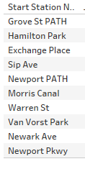

This may be because there are connector stations where you can switch lines.

* Today, what are the top 10 stations in the city for ending a journey? (Based on data, why?)
  + The top stations to end a journey are:

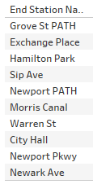

This may be because this is where most commuters go to in order to catch a train. Most of these are also major connector stations.

* Today, what are the bottom 10 stations in the city for starting a journey? (Based on data, why?)
  + The bottom starts to start a journey are:
  + 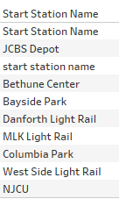

This could be because these stations or very remote and does not have a lot of traffic or riders.

* Today, what are the bottom 10 stations in the city for ending a journey (Based on data, why?)
  + The bottom 10 stations to end a journey are:
  + 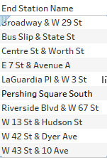

This could be because there are no statins near by so no one is traveling there to get onto a train. This could also be residential areas so there is no need to travel there unless you live there.

* Today, what is the gender breakdown of active participants (Male v. Female)?
  + For 2017, there were 212,709 males, 61,294 females, and 20,925 unknown riders.
* How effective has gender outreach been in increasing female ridership over the course of the past three years?
  + The gender outreach has been effective as there has been an increase if females riders year over year but it’s a very seasonal stat as they increase during the summer months and reduce during colder months.
* How does the average trip duration change by age?
  + The average trip spikes at 20 and then reduces back to norm after 25. This makes sense, as the individuals with the most time to be able to take longer bike riders are in that age range.
* What is the average distance in miles that a bike is ridden?
* Which Bikes (by ID) are most likely due for repair or inspection this year?
  + These are the most used bikes with the most amount of trips so they are due for inspection.
  + 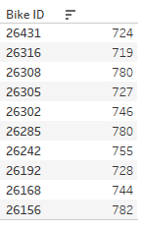
* How variable is the utilization by bike ID?